**PRACTICAL NO.2**

1. **Design asp.net web form to demonstrate various events in asp.net page life cycle.**

**Practical2.1.aspx**

<%@ Page Language="C#" AutoEventWireup="true" CodeBehind="practical2.1.aspx.cs" Inherits="Practical2.practical2__1" %>

<!DOCTYPE html>

<html xmlns="http://www.w3.org/1999/xhtml">

<head runat="server">

<title></title>

</head>

<body>

<form id="form1" runat="server">

<div>

<asp:Label ID="lblName" runat="server" ></asp:Label>

<br/>

<asp:Button ID="btnSubmit" runat="server" Text="Submit"

OnClick="btnSubmit_Click" />

</div>

</form>

</body>

</html>

**Practical2.2.1.aspx**

<%@ Page Language="C#" AutoEventWireup="true" CodeBehind="practical2.2.1.aspx.cs" Inherits="Practical2.practical2__2__1" %>

<!DOCTYPE html>

<html xmlns="http://www.w3.org/1999/xhtml">

<head runat="server">

<title></title>

</head>

<body>

<form id="form1" runat="server">

<div>

<b> <asp:Label ID="Label2" runat="server" Text="Cross-page Posting

Example"></asp:Label> </b>

<br />

<asp:Label ID="Label1" runat="server" Text="Label"></asp:Label>

</div>

</form>

</body>

</html>

**Practical2.1.aspx.cs**

using System;

using System.Collections.Generic;

using System.Linq;

using System.Web;

using System.Web.UI;

using System.Web.UI.WebControls;

namespace Practical2

{

public partial class practical2__1 : System.Web.UI.Page

{

protected void Page_PreInit(object sender, EventArgs e)

{

//System.Threading.Thread.Sleep(3000);

lblName.Text = lblName.Text + "<br/>" + "PreInit";

}

protected void Page_Init(object sender, EventArgs e)

{

//System.Threading.Thread.Sleep(3000);

lblName.Text = lblName.Text + "<br/>" + "Init";

}

protected void Page_InitComplete(object sender, EventArgs e)

{

//System.Threading.Thread.Sleep(3000);

lblName.Text = lblName.Text + "<br/>" + "InitComplete";

}

protected override void OnPreLoad(EventArgs e)

{

//System.Threading.Thread.Sleep(3000);

//If the page is post back, then label contrl values will be loaded from view

//state.

//E.g: If you string str = lblName.Text, then str will contain viewstate

//values.

lblName.Text = lblName.Text + "<br/>" + "PreLoad";

}

protected void Page_Load(object sender, EventArgs e)

{

//System.Threading.Thread.Sleep(3000);

lblName.Text = lblName.Text + "<br/>" + "Load";

}

protected void Page_LoadComplete(object sender, EventArgs e)

{

//System.Threading.Thread.Sleep(3000);

lblName.Text = lblName.Text + "<br/>" + "LoadComplete";

}

protected override void OnPreRender(EventArgs e)

{

System.Threading.Thread.Sleep(3000);

lblName.Text = lblName.Text + "<br/>" + "PreRender";

}

protected override void OnSaveStateComplete(EventArgs e)

{

//System.Threading.Thread.Sleep(3000);

//But "SaveStateComplete" values will not be available during post back. i.e.

//View state.

lblName.Text = lblName.Text + "<br/>" + "SaveStateComplete";

}

protected void Page_UnLoad(object sender, EventArgs e)

{

//System.Threading.Thread.Sleep(3000);

//it will not effect label contrl, view state and post back data.

lblName.Text = lblName.Text + "<br/>" + "UnLoad";

}

protected void btnSubmit_Click(object sender, EventArgs e)

{

//lblName.ForeColor = System.Drawing.Color.Red;

//System.Threading.Thread.Sleep(3000);

lblName.Text = lblName.Text + "<br/>" + "btnSubmit_Click";

}

}

}

**Practical2.1.1.aspx.cs**

using System;

using System.Collections.Generic;

using System.Linq;

using System.Web;

using System.Web.UI;

using System.Web.UI.WebControls;

namespace Practical2

{

public partial class practical2__2__1 : System.Web.UI.Page

{

protected void Page_Load(object sender, EventArgs e)

{

if (Page.PreviousPage != null && PreviousPage.IsCrossPagePostBack)

{

//creating control at run-time

Calendar Cal1 = new Calendar();

TextBox txtMyName = new TextBox();

Cal1 = (Calendar)(PreviousPage.FindControl("Calendar1"));

txtMyName = (TextBox)(PreviousPage.FindControl("txtName"));

Label1.Text = "<br/>Hi " + txtMyName.Text + ", Here is output of the Cross Page Post Back Button: " + Cal1.SelectedDate.ToString("dd / MM / yyyy");

}

}

}

}

**Output:**

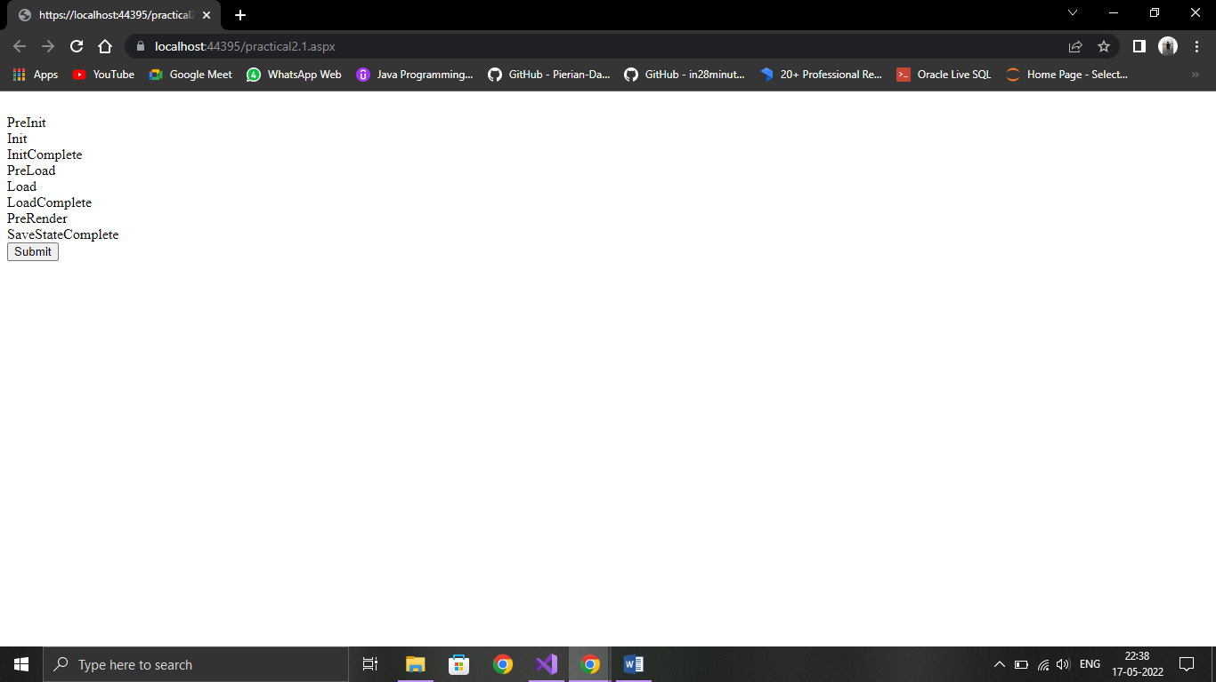

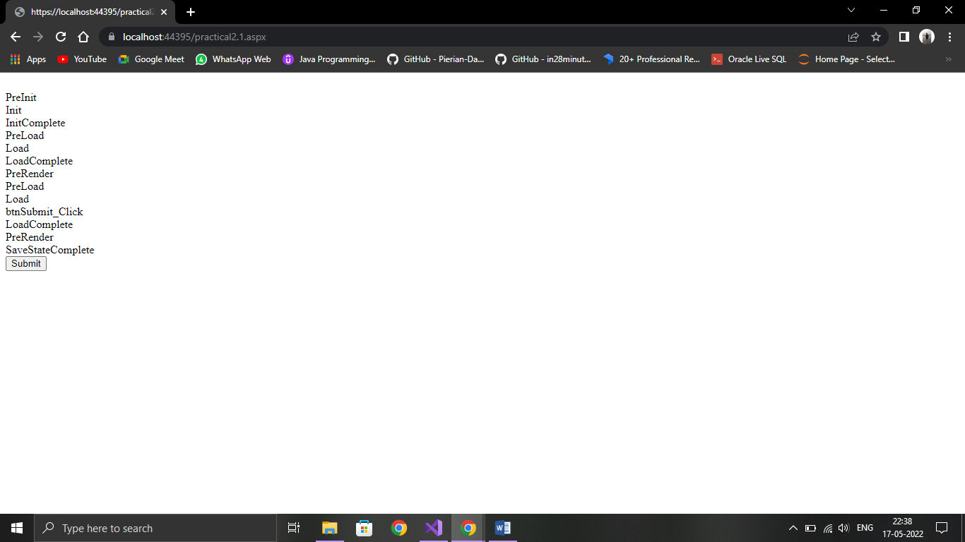

1. **Design asp.net web form to demonstrate postback posting, cross-page posting and auto postback.**

**Practical2.2.aspx**

<%@ Page Language="C#" AutoEventWireup="true" CodeBehind="practical2.2.aspx.cs" Inherits="Practical2.practical2__2" %>

<!DOCTYPE html>

<html xmlns="http://www.w3.org/1999/xhtml">

<head runat="server">

<title></title>

</head>

<body>

<form id="form1" runat="server">

<div>

Enter your Name :

<asp:TextBox ID="txtName" runat="server"></asp:TextBox>

<asp:Calendar ID="Calendar1" runat="server" NextMonthText="&amp;gt;&amp;gt;"

PrevMonthText="&amp;lt;&amp;lt;"></asp:Calendar>

</div>

<asp:Button ID="btnPostBack_Posting" runat="server" Text="Same Page Post Back"

OnClick="btnPostBack_Posting_Click" />

&nbsp;&nbsp;&nbsp;

<asp:Button ID="btnCrossPage_Posting" runat="server" Text="Cross Page Post Back"

PostBackUrl="~/practical2.2.1.aspx" OnClick="btnCrossPage_Posting_Click" />

<p>

<asp:Label ID="Label1" runat="server" Text="Label"></asp:Label>

</p>

</form>

</body>

</html>

**Practical2.2.1.aspx**

<%@ Page Language="C#" AutoEventWireup="true" CodeBehind="practical2.2.1.aspx.cs" Inherits="Practical2.practical2__2__1" %>

<!DOCTYPE html>

<html xmlns="http://www.w3.org/1999/xhtml">

<head runat="server">

<title></title>

</head>

<body>

<form id="form1" runat="server">

<div>

<b> <asp:Label ID="Label2" runat="server" Text="Cross-page Posting

Example"></asp:Label> </b>

<br />

<asp:Label ID="Label1" runat="server" Text="Label"></asp:Label>

</div>

</form>

</body>

</html>

**Practical2.2.aspx.cs**

using System;

using System.Collections.Generic;

using System.Linq;

using System.Web;

using System.Web.UI;

using System.Web.UI.WebControls;

namespace Practical2

{

public partial class practical2__2 : System.Web.UI.Page

{

protected void Page_Load(object sender, EventArgs e)

{

}

protected void btnPostBack_Posting_Click(object sender, EventArgs e)

{

Label1.Text = "Hi " + txtName.Text + ", Here is output of the Same Page Post Back Button : " + Calendar1.SelectedDate.ToString("dd / MM / yyyy");

}

protected void btnCrossPage_Posting_Click(object sender, EventArgs e)

{

}

}

}

**Practical2.2.1.aspx.cs**

using System;

using System.Collections.Generic;

using System.Linq;

using System.Web;

using System.Web.UI;

using System.Web.UI.WebControls;

namespace Practical2

{

public partial class practical2__2__1 : System.Web.UI.Page

{

protected void Page_Load(object sender, EventArgs e)

{

if (Page.PreviousPage != null && PreviousPage.IsCrossPagePostBack)

{

//creating control at run-time

Calendar Cal1 = new Calendar();

TextBox txtMyName = new TextBox();

Cal1 = (Calendar)(PreviousPage.FindControl("Calendar1"));

txtMyName = (TextBox)(PreviousPage.FindControl("txtName"));

Label1.Text = "<br/>Hi " + txtMyName.Text + ", Here is output of the Cross Page Post Back Button: " + Cal1.SelectedDate.ToString("dd / MM / yyyy");

}

}

}

}

**Output:**

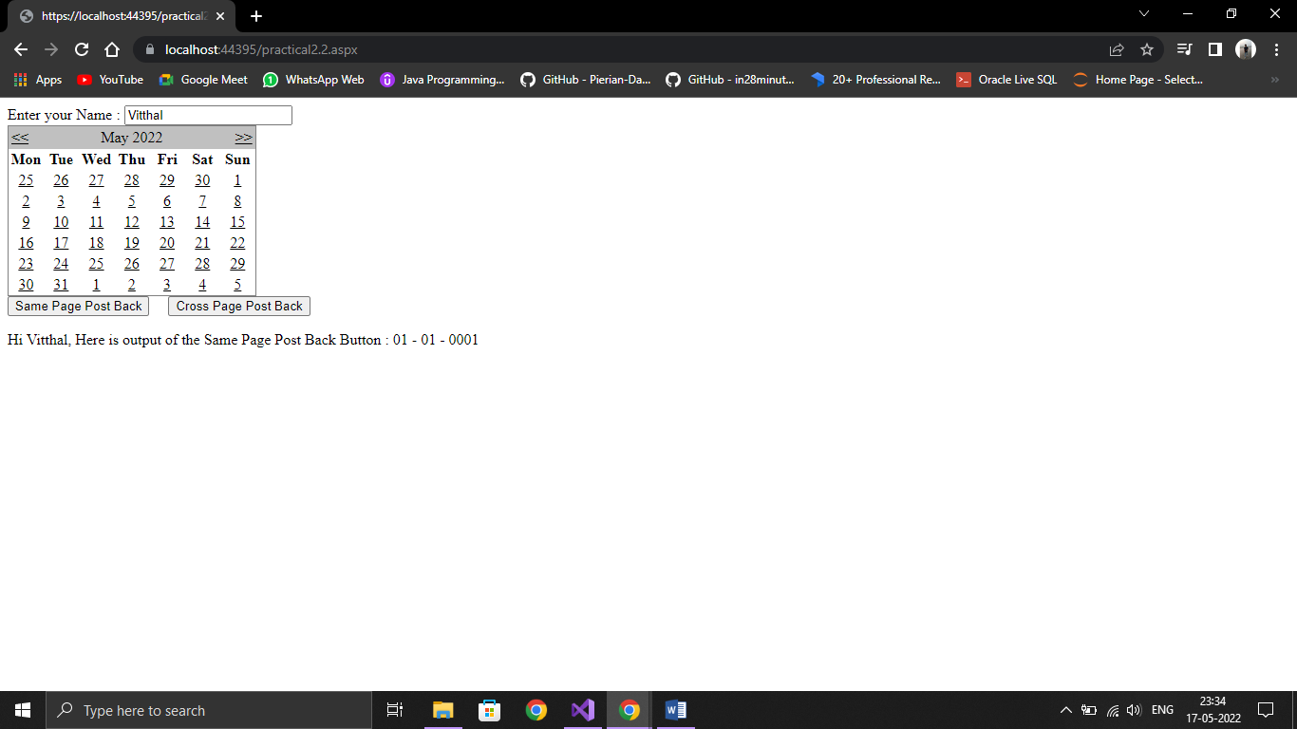

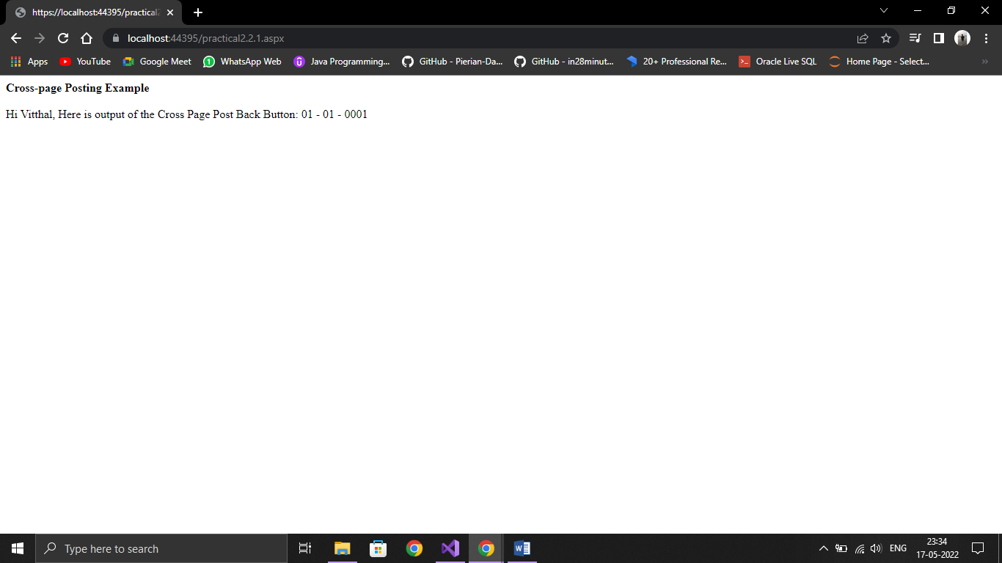

1. **Design asp.net web form to demonstrate FileUpload, Calendar and AdRotator controls.**

**Practical2.3.aspx**

<%@ Page Language="C#" AutoEventWireup="true" CodeBehind="practical2.3.aspx.cs" Inherits="Practical2.practical2__3" %>

<!DOCTYPE html>

<html xmlns="http://www.w3.org/1999/xhtml">

<head runat="server">

<title></title>

</head>

<body>

<form id="form1" runat="server">

<div>

<h3> File Upload:</h3>

<br />

<asp:FileUpload ID="FileUpload1" runat="server" />

<br /> <br />

<asp:Button ID="btnSave" runat="server" Text="Save"

style="width:85px" OnClick="btnSave_Click" />

<br /><br />

<asp:Label ID="lblMessage" runat="server" />

</div>

</form>

</body>

</html>

**Practical2.3.1.aspx**

<%@ Page Language="C#" AutoEventWireup="true" CodeBehind="practical2.3.1.aspx.cs" Inherits="Practical2.practical2__3__1" %>

<!DOCTYPE html>

<html xmlns="http://www.w3.org/1999/xhtml">

<head runat="server">

<title></title>

</head>

<body>

<form id="form1" runat="server">

<div>

AdRotator Demo<br />

</div>

<asp:AdRotator ID="AdRotator1" runat="server" BorderStyle="Solid" Height="200px"

Width="1200px" AdvertisementFile="~/XMLFile1.xml" />

</form>

</body>

</html>

**Practical2.3.aspx.cs**

using System;

using System.Collections.Generic;

using System.IO;

using System.Linq;

using System.Text;

using System.Web;

using System.Web.UI;

using System.Web.UI.WebControls;

namespace Practical2

{

public partial class practical2__3 : System.Web.UI.Page

{

protected void Page_Load(object sender, EventArgs e)

{

}

protected void btnSave_Click(object sender, EventArgs e)

{

StringBuilder sb = new StringBuilder();

if (FileUpload1.HasFile)

{

try

{

sb.AppendFormat(" Uploading file: {0}", FileUpload1.FileName);

//saving the file

string filename = Path.GetFileName(FileUpload1.FileName);

FileUpload1.SaveAs(Server.MapPath("~/") + filename);

//Showing the file information

sb.AppendFormat("<br/> Save As: {0} ",

FileUpload1.PostedFile.FileName);

sb.AppendFormat("<br/> File type: {0}",

FileUpload1.PostedFile.ContentType);

sb.AppendFormat("<br/> File length: {0}",

FileUpload1.PostedFile.ContentLength);

}

catch (Exception ex)

{

sb.Append("<br/> Error <br/>");

sb.AppendFormat("Unable to save file <br/> {0}", ex.Message);

}

}

lblMessage.Text = sb.ToString();

}

}

}

**Practical2.3.1.aspx.cs**

using System;

using System.Collections.Generic;

using System.Linq;

using System.Web;

using System.Web.UI;

using System.Web.UI.WebControls;

namespace Practical2

{

public partial class practical2__3__1 : System.Web.UI.Page

{

protected void Page_Load(object sender, EventArgs e)

{

}

}

}

**Output:**

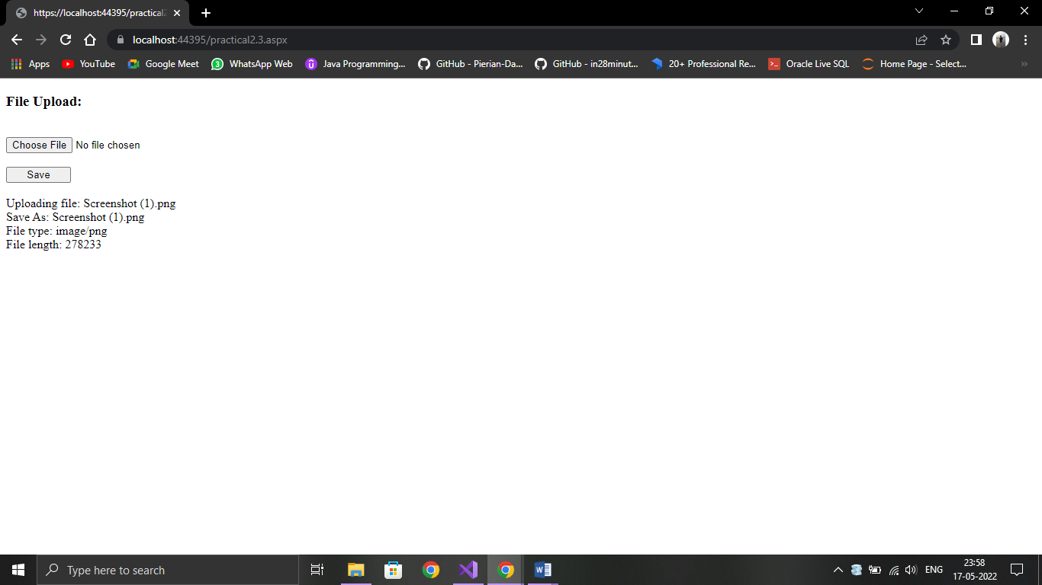

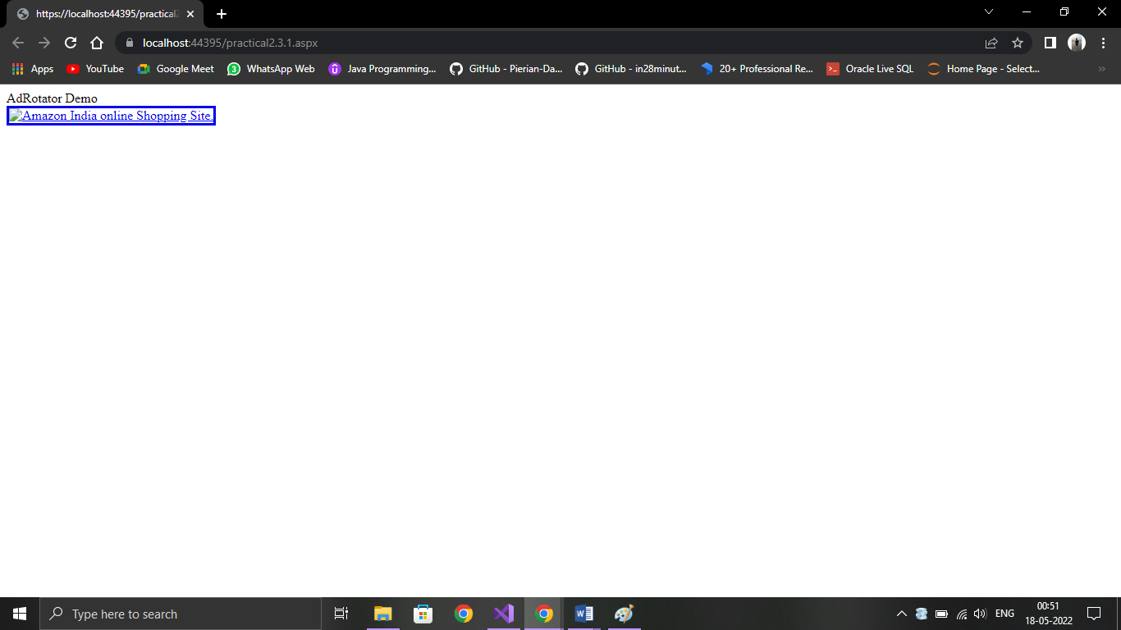

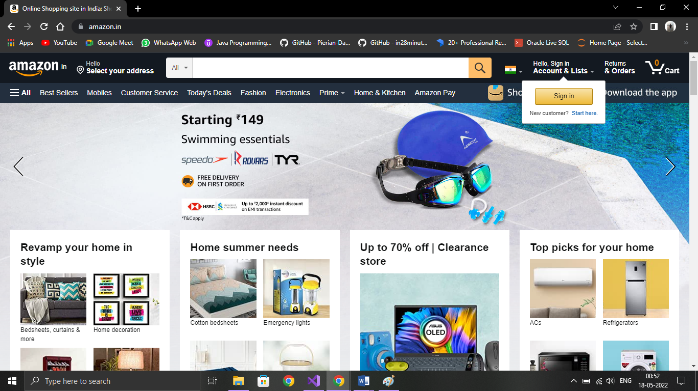

CalenderControl.aspx

<%@ Page Language="C#" AutoEventWireup="true" CodeBehind="CalenderControl.aspx.cs" Inherits="practical2_A.CalenderControl" %>

<!DOCTYPE html>

<html xmlns="http://www.w3.org/1999/xhtml">

<head runat="server">

<title></title>

</head>

<body>

<form id="form1" runat="server">

<div>

<asp:Calendar ID="Calendar1" runat="server" BackColor="#CCFFFF" BorderStyle="Double" ForeColor="#000066" OnSelectionChanged="Calendar1_SelectionChanged"></asp:Calendar>

<br />

<br />

<p>Selected Date is:</p><asp:Label ID="LblDate" runat="server" Text="Label"></asp:Label>

</div>

</form>

</body>

</html>

CalenderControl.aspx.cs

using System;

using System.Collections.Generic;

using System.Linq;

using System.Web;

using System.Web.UI;

using System.Web.UI.WebControls;

namespace practical2

{

public partial class CalenderControl : System.Web.UI.Page

{

protected void Calendar1_SelectionChanged(object sender, EventArgs e)

{

LblDate.Text = Calendar1.SelectedDate.ToShortDateString();

}

}

}

Output:

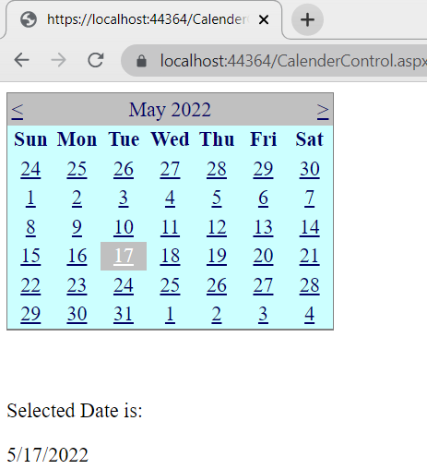

1. **Design asp.net web form to demonstrate Validation controls in asp.net. After successful submission of data, show same data on another page.**

**Practical2.4.aspx**

<%@ Page Language="C#" AutoEventWireup="true" CodeBehind="practical2.4.aspx.cs" Inherits="Practical2.practical2__4" %>

<!DOCTYPE html>

<html xmlns="http://www.w3.org/1999/xhtml">

<head runat="server">

<title></title>

</head>

<body>

<form id="form1" runat="server">

<div>

<asp:Label ID="lblhead" runat="server" Text="Validation Controls" Font-Bold="true" Font-Size="Large"></asp:Label>

<br /><br />

<asp:Label ID="lblname" runat="server" Text="Enter Your Name:"></asp:Label>

&nbsp;&nbsp;&nbsp;&nbsp;

<asp:TextBox ID="txtname" runat="server"></asp:TextBox>

&nbsp;&nbsp;&nbsp;&nbsp;

<asp:RequiredFieldValidator ID="RequiredFieldValidator1" runat="server" ControlToValidate="txtname" ErrorMessage="Name is mandatory" ForeColor="Red"></asp:RequiredFieldValidator>

<br /><br />

<asp:Label ID="lblpass" runat="server" Text="Enter Password:"></asp:Label>

&nbsp;&nbsp;&nbsp;&nbsp;

<asp:TextBox ID="txtpass" runat="server" TextMode="Password"></asp:TextBox>

&nbsp;&nbsp;&nbsp;&nbsp;

<asp:RequiredFieldValidator ID="RequiredFieldValidator2" runat="server" ErrorMessage="Please Enter PassWord" ForeColor="Red" ControlToValidate="txtpass">Password Is Mandatory</asp:RequiredFieldValidator>

<br /><br />

<asp:Label ID="lblconfirm" runat="server" Text="Confirm Password:"></asp:Label>

&nbsp;&nbsp;&nbsp;&nbsp;

<asp:TextBox ID="txtconfirm" runat="server" TextMode="Password"></asp:TextBox>

&nbsp;&nbsp;&nbsp;&nbsp;

<asp:RequiredFieldValidator ID="RequiredFieldValidator3" runat="server" ErrorMessage="Plaese Confirm Password" ForeColor="Red" ControlToValidate="txtconfirm">Confrim Password</asp:RequiredFieldValidator>

&nbsp;&nbsp;&nbsp;&nbsp;

<asp:CompareValidator ID="CompareValidator1" runat="server" ErrorMessage="Password not matched" ControlToCompare="txtpass" ControlToValidate="txtconfirm" ForeColor="Red"></asp:CompareValidator>

<br /><br />

<asp:Label ID="lblage" runat="server" Text="Enter Your Age:"></asp:Label>

&nbsp;&nbsp;&nbsp;&nbsp;

<asp:TextBox ID="txtage" runat="server"></asp:TextBox>

&nbsp;&nbsp;&nbsp;&nbsp;

<asp:RangeValidator ID="RangeValidator1" runat="server" ControlToValidate="txtage" ErrorMessage="Age must be in range &amp;gt;= 18 and &amp;lt;=50 !" ForeColor="Red" MaximumValue="50" MinimumValue="18" Type="Integer" Display="Dynamic">>Age must be in range &gt;= 18 and &lt;=50!</asp:RangeValidator>

<br /><br />

<asp:Label ID="lblemail" runat="server" Text="Enter Your Email:"></asp:Label>

&nbsp;&nbsp;&nbsp;&nbsp;

<asp:TextBox ID="txtemail" runat="server"></asp:TextBox>

&nbsp;&nbsp;&nbsp;&nbsp;

<asp:RegularExpressionValidator ID="RegularExpressionValidator1" runat="server" ErrorMessage="Please enter proper email-id!" ControlToValidate="txtemail" ValidationExpression="\w+([-+.']\w+)@\w+([-.]\w+)\.\w+([-.]\w+)*" Display="Dynamic" ForeColor="Red">Please Enter Proper Email</asp:RegularExpressionValidator>

<br /><br />

<asp:Button ID="btnsubmit" Text="Submit" PostBackUrl="~/practical2.4.aspx" runat="server" OnClick="btnsubmit_Click" />

</div>

</form>

</body>

</html>

**Practical2.4.1.aspx**

<%@ Page Language="C#" AutoEventWireup="true" CodeBehind="practical2.4.1.aspx.cs" Inherits="Practical2.practical2__4__1" %>

<!DOCTYPE html>

<html xmlns="http://www.w3.org/1999/xhtml">

<head runat="server">

<title></title>

</head>

<body>

<form id="form1" runat="server">

<div>

<asp:Label ID="lblName" runat="server"></asp:Label>

<br /><br />

<asp:Label ID="lblPass" runat="server"></asp:Label>

<br /><br />

<asp:Label ID="lblAge" runat="server"></asp:Label>

<br /><br />

<asp:Label ID="lblEmail" runat="server"></asp:Label>

<br /><br />

</div>

</form>

</body>

</html>

**Practical2.4.aspx.cs**

using System;

using System.Collections.Generic;

using System.Linq;

using System.Web;

using System.Web.UI;

using System.Web.UI.WebControls;

namespace Practical2

{

public partial class practical2__4 : System.Web.UI.Page

{

protected void Page_Load(object sender, EventArgs e)

{

if (Page.PreviousPage != null && PreviousPage.IsCrossPagePostBack)

{

TextBox txtMyName = new TextBox();

txtMyName = (TextBox)(PreviousPage.FindControl("txtname"));

lblname.Text = "Name: " + txtMyName.Text;

TextBox txtMyPass = new TextBox();

txtMyPass = (TextBox)(PreviousPage.FindControl("txtpass"));

lblpass.Text = "Password: " + txtMyPass.Text;

TextBox txtMyAge = new TextBox();

txtMyAge = (TextBox)(PreviousPage.FindControl("txtage"));

lblage.Text = "Age: " + txtMyAge.Text;

TextBox txtMyEmail = new TextBox();

txtMyEmail = (TextBox)(PreviousPage.FindControl("txtemail"));

lblemail.Text = "Email: " + txtMyEmail.Text;

}

}

}

}

**Practical2.4.1.aspx.cs**

using System;

using System.Collections.Generic;

using System.Linq;

using System.Web;

using System.Web.UI;

using System.Web.UI.WebControls;

namespace Practical2

{

public partial class practical2__4__1 : System.Web.UI.Page

{

protected void Page_Load(object sender, EventArgs e)

{

}

}

}

**Output:**

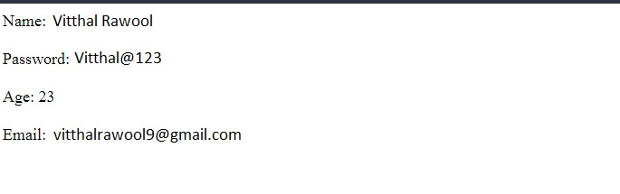

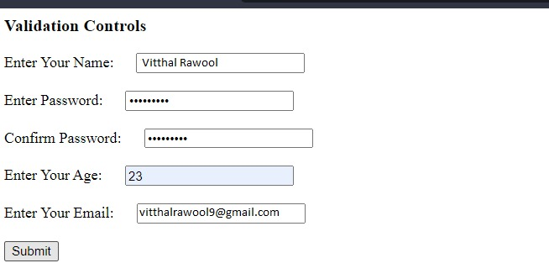

**6**. **Design asp.net web form to demonstrate JQuery (use CDN JQuery library).**

**Design:**

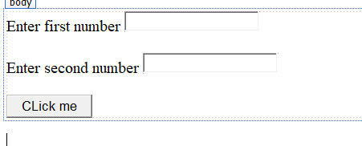

**Code:**

**JQueryCDN.aspx:**

<%@ Page Language="C#" AutoEventWireup="true" CodeBehind="JQueryCDN.aspx.cs" Inherits="Practical2.JQueryCDN" %>

<!DOCTYPE html>

<html xmlns="http://www.w3.org/1999/xhtml">

<head runat="server">

<title></title>

<script src="Scripts/jquery-3.2.1.js"></script>

<script>

$(document).ready(function () {

$("button").click(function () {

var num1 = $("#num1").val();

var num2 = $("#num2").val();

var sum = parseInt(num1) + parseInt(num2);

alert("Addition is : "+sum);

});

});

</script>

</head>

<body>

<form id="form1" runat="server">

<div>

<asp:Label ID="Label1" runat="server" Text="Enter first number"></asp:Label>

&nbsp;<input type="text" id="num1" placeholder="Enter first number"/></br></br>

<asp:Label ID="Label2" runat="server" Text="Enter second number"></asp:Label>

&nbsp;<input type="text" id="num2" placeholder="Enter Second number"/></br></br>

<button>CLick me</button>

</div>

</form>

</body>

</html>

**Output:**

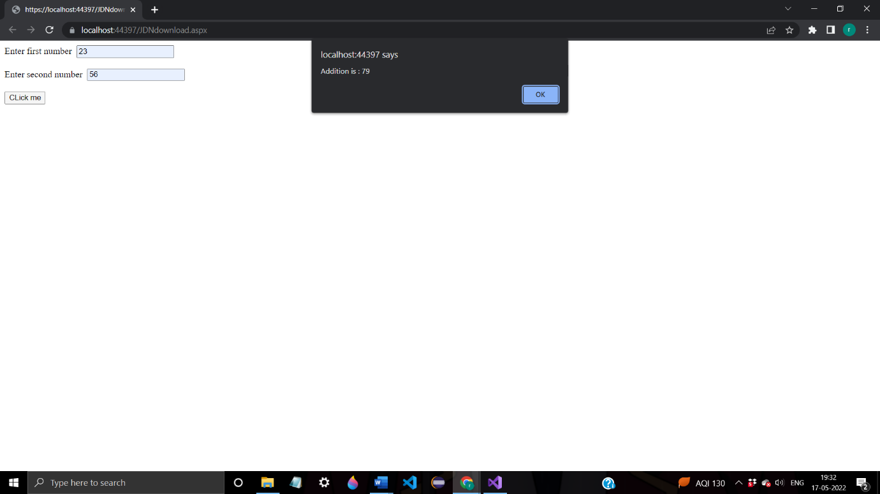

**7. Design asp.net web form to demonstrate JQuery (download and use local JQuery library).**

<%@ Page Language="C#" AutoEventWireup="true" CodeFile="JQueryLocal.aspx.cs" Inherits="JQueryLocal" %>

<!DOCTYPE html>

<script type="text/javascript" src="/Scripts/jquery-3.6.0.min.js"></script>

<script type="text/javascript" >

$(document).ready(function ()

{

$("#btnSubmit").click(function ()

{ alert("Alert using jQuery"); });

});

</script>

<html xmlns="http://www.w3.org/1999/xhtml">

<head runat="server">

<title></title>

</head>

<body>

<form id="form1" runat="server">

<div>

</div>

<p>

<asp:Button ID="btnSubmit" runat="server" Text="Submit" />

</p>

</form>

</body>

</html>

**Output:**

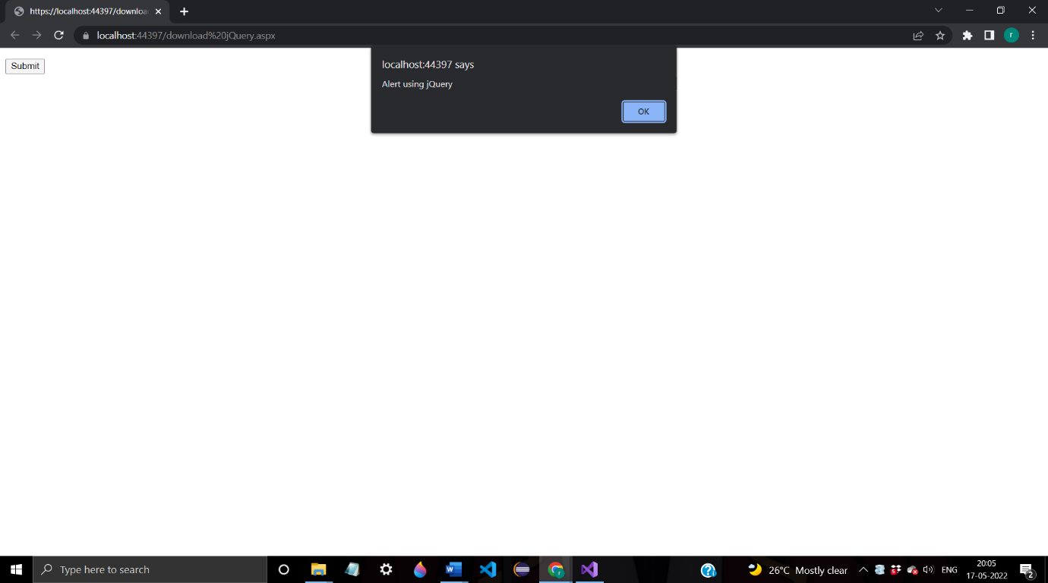

**8. Design asp.net web form to demonstrate AngularJS (use CDN).**

<%@ Page Language="C#" AutoEventWireup="true" CodeFile="AngularJsCDN.aspx.cs" Inherits="AngularJsCDN" %>

<!DOCTYPE html>

<html xmlns="http://www.w3.org/1999/xhtml">

<head runat="server">

<title>AngularJS Demo</title>

</head>

<script src="https://ajax.googleapis.com/ajax/libs/angularjs/1.6.9/angular.min.js"></script>

<body>

<form id="form1" runat="server">

<div ng-app="">

<p>Name : <input type="text" ng-model="name"></p>

<h1>Hello **{{**name**}}**</h1>

</div>

</form>

</body>

</html>

Output:

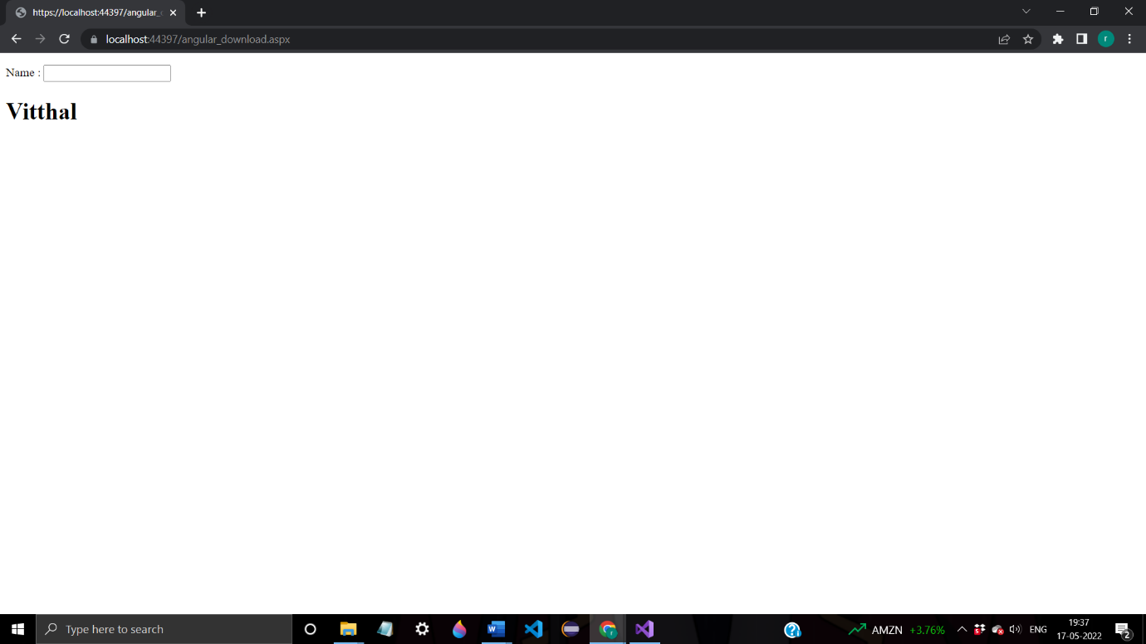

**9. Design asp.net web form to demonstrate AngularJS (download and use local library).**

<%@ Page Language="C#" AutoEventWireup="true" CodeFile="AngularJsLocal.aspx.cs" Inherits="AngularJsLocal" %>

<!DOCTYPE html>

<html xmlns="http://www.w3.org/1999/xhtml">

<head runat="server">

<title>Angular Js Demo</title>

<script src="Scripts/angular.min.js"></script>

</head>

<body ng-app="">

<h2>Arithmetic Expression In AngularJS</h2>

<br />

<h3>Addition</h3>

10 + 20 = **{{**10+20**}}**

<br />

<h3>Subtraction</h3>

30 - 20 = **{{**30-20**}}**

<br />

<h3>Multiply</h3>

10 * 20 = **{{**10*20**}}**

<br />

<h3>Division</h3>

20 / 10 = **{{**20/10**}}**

</body>

</html>

Output:

